DEALS TO MONTEREY

The city of Monterey is famous for its aquarium and Cannery Row, but these attractions are just the beginning. With so many fun and unique things to do in Monterey, it can be difficult to narrow down your list.

(MARKET IMAGE HERE)

Find Deals From These Cities

INSERT FARE GRID FROM / TO Version (if available!)

   
Top Things To Do in Monterey

To make it a bit easier, refer to these top attractions below the next time you’re trying to decide what to see in Monterey, CA.

* Visit “one of the most enchanting aquariums in the world”, according to Forbes Traveler. The interactive exhibits and other surprising discoveries at the Monterey Bay Aquarium are enjoyed by all ages.
* Explore Pebble Beach. This community offers gourmet restaurants, upscale spas, boutique shopping, championship golf courses and more. While there, take the 17-Mile Drive - one of the world’s most well known scenic drives.
* Walk along Cannery Row, and take in the various eateries, wine tasting rooms, hotels, specialty stores and art galleries along this scenic waterfront stretch.

Travel Tips and Resources

[Monterey Aquarium](http://www.montereybayaquarium.org/)

[Must-Dos in Montereyhttp://www.tripadvisor.com/Attractions-g32737-Activities-Monterey_Monterey_Peninsula_California.html](http://www.tripadvisor.com/Attractions-g32737-Activities-Monterey_Monterey_Peninsula_California.html)

[Monterey Hotelshttp://www.tripadvisor.com/Hotels-g32737-Monterey_Monterey_Peninsula_California-Hotels.html](http://www.tripadvisor.com/Hotels-g32737-Monterey_Monterey_Peninsula_California-Hotels.html)

[Monterey Restaurantshttp://www.tripadvisor.com/Restaurants-g32737-Monterey_Monterey_Peninsula_California.html](http://www.tripadvisor.com/Restaurants-g32737-Monterey_Monterey_Peninsula_California.html)

[Monterey Shopping Guidehttp://www.tripadvisor.com/Attractions-g32737-Activities-c26-Monterey_Monterey_Peninsula_California.html](http://www.tripadvisor.com/Attractions-g32737-Activities-c26-Monterey_Monterey_Peninsula_California.html)

[Monterey Nightlife and Entertainmenthttp://www.seemonterey.com/things-to-do/nightlife](http://www.seemonterey.com/things-to-do/nightlife)

[Monterey Travel Tipshttp://travel.usnews.com/Monterey_CA/Travel_Tips](http://travel.usnews.com/Monterey_CA/Travel_Tips)

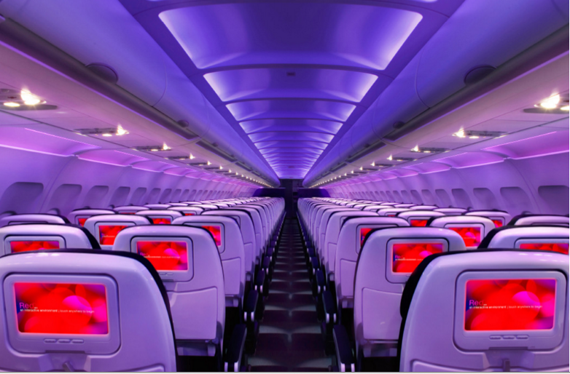

Main Cabin Main Cabin Select First Class

(add links to Cabin Class Pages)

Ready. Set. Fly.

Book your Mood-lit Ride to Monterey.

Flying to San Francisco International Airport and renting a car is the easiest way to Monterey. Book Virgin America flights to Monterey, CA and experience a better way to fly from check-in to baggage claim. Virgin America’s custom designed leather seats, mood-lit cabins and on-demand WiFi let you truly relax on your way to the Bay Area. Take a virtual tour to see our amenities for yourself.

Take a Virtual Tour

Add Terms & Conditions